**CE101 Engineering Drawing July- Nov 2019**

**Indian Institute of Technology Guwahati**

**Lab Sheet-9 Development of Surfaces Friday Morning**

**Full Marks: 100 Date:25.10.2019**

1. Draw the development of the complete surface of a hexagonal pyramid of base 30 mm and height 70 mm showing its FV & TV. (15 Marks)
2. Draw the development of the lateral surface of the cylinder whose top view as shown in figure below. (35 Marks)

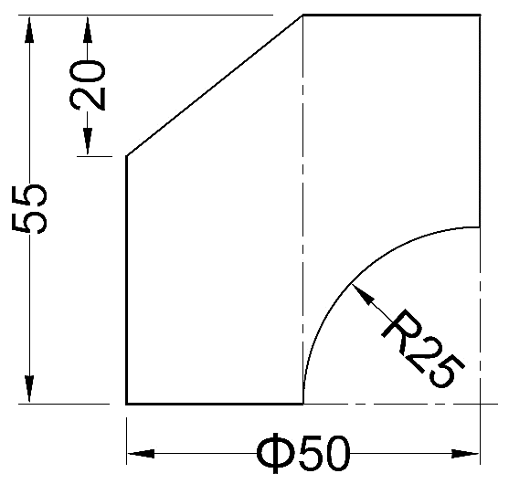

1. A pentagonal prism of base side 30 mm and axis 75 mm stands on its base on the ground such that one of its rectangular faces is parallel to and nearer the VP. A thread is wound around the prism, starting from the corner of the lower base farthest away from the VP to the corresponding corner of the upper base. Find the minimum length of the thread and show it on the front view of the prism. (50 Marks)